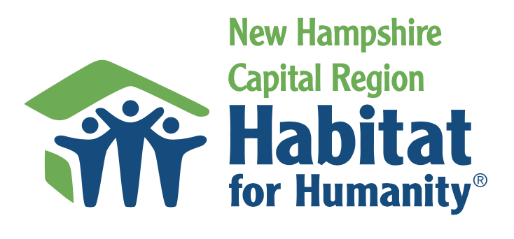

The New Hampshire Capital Region Habitat for Humanity (CRHFH) affiliate is currently renovating one property annually and selling it to a worthy low-income household. Our focus is renovation of single-wide manufactured homes, as these properties offer the lowest cost of ownership.

Minimum Criteria:

Following are the minimum requirements for a household to be considered as a candidate to buy a renovated property:

- Lives or works in the CRHFH service area, which includes 16 towns (Boscawen, Bow, Canterbury, Chichester, Concord, Dunbarton, Epsom, Henniker, Hopkinton, Loudon, Pembroke, Penacook, Pittsfield, Salisbury, Warner, and Webster).
- Annual income is not higher than 80% of the Area Median Income. Based on HUD data as of 2021, a household of one person in Merrimack County must earn less than $52,450 to qualify as a CRHFH candidate.
- Willing to take financial education courses that improve a homeowner’s long-term probability of success.
- Agrees to provide sweat equity toward the renovation of a CRHFH property.

Overview of the Homeowner Selection Process:

Prior to completion of the renovation process, our affiliate lists the property for sale on the Multiple Listing Service (MLS). Potential candidates are provided with an application which must be completed and received typically within three weeks after the MLS listing is posted.

The Homeowner Selection Committee will review each application. For every applicant meeting the minimum criteria, the Committee will use an objective scoring tool to identify the candidate with the greatest need, that can still afford the property. This Committee evaluates factors such as:

- Total annual income
- Total assets
- Current housing cost as a percent of income
- Total debt to income as a percent of income
- Satisfactory criminal background check
- Satisfactory sex offender background check
- Size of household
- Status of current living conditions (based on a home visit)
- Agrees to sweat equity requirements
- Agrees to take financial education courses
- Total housing cost of Habitat property is no more than 30% of income
- Total debt and housing cost, assuming the purchase of the renovated property, does not exceed 45% of income

Housing Cost

Housing cost includes:

- Mortgage
- Park lot fees (for manufactured homes)
- Real estate tax
- Homeowner’s insurance

Housing cost must not exceed 30% of a candidate’s income, because housing costs that exceed this limit may result in a household defaulting on the payment of one or more of these monthly obligations.

The CRHFH will adjust the proposed sales price of the renovated property for the selected candidate so that the total housing cost does not exceed the 30% limit.

